Breast Cancer Prediction Using Machine Learning CETM2 – Data Science Principles

1. Introduction
Breast cancer is one of the most common cancers in the world and early diagnosis can make a significant difference to a person's treatment and recovery this topic is facinant to me , because it is something that genuinely interests me. I have friends whose families have been affected by breast cancer, and seeing how difficult the disease can be made me interested in how technology and data science can help improve early detection. This motivated me to investigate how machine learning can be used to support medical decision-making.The aim of this project is to investigate how different machine learning algorithms can classify breast cancer cases using the Wisconsin Breast Cancer dataset from the UCI Machine Learning Repository,the project was completed using the R programming language in RStudio,before building the models, I explored and pre processed the dataset by checking its structure, identifying missing values, removing unnecessary information and preparing the data for classification. I then developed a Decision Tree model and a Random Forest model and evaluated their performance using confusion matrices, prediction accuracy and a ROC curve to determine which algorithm produced the most reliable results.

2. Application Area and Data
This project focuses on using machine learning to help classify breast cancer as either benign or malignant. In this application I wanted to learn how data science can be used to solve real healthcare problems, as I mentioned earlier, I also have friends whose families have been affected by breast cancer which made me interested in understanding how machine learning could support earlier diagnosis and improve decision making.The dataset used in this project is the Wisconsin Breast Cancer dataset from the UCI Machine Learning Repository (Dua and Graff, 2019). It contains information collected from breast cell samples, including characteristics such as cell size, cell shape, marginal adhesion, epithelial cell size, bare nuclei, bland chromatin, normal nucleoli and mitoses. The target variable is Class, which identifies whether a tumour is benign or malignant. Before building the machine learning models, I explored the dataset using the head(), str(), summary() and dim() functions to better understand the data. I also checked for missing values removed the ID column because it was not useful for prediction, converted the Class variable into a factor and removed incomplete records before splitting the dataset into training and testing sets.

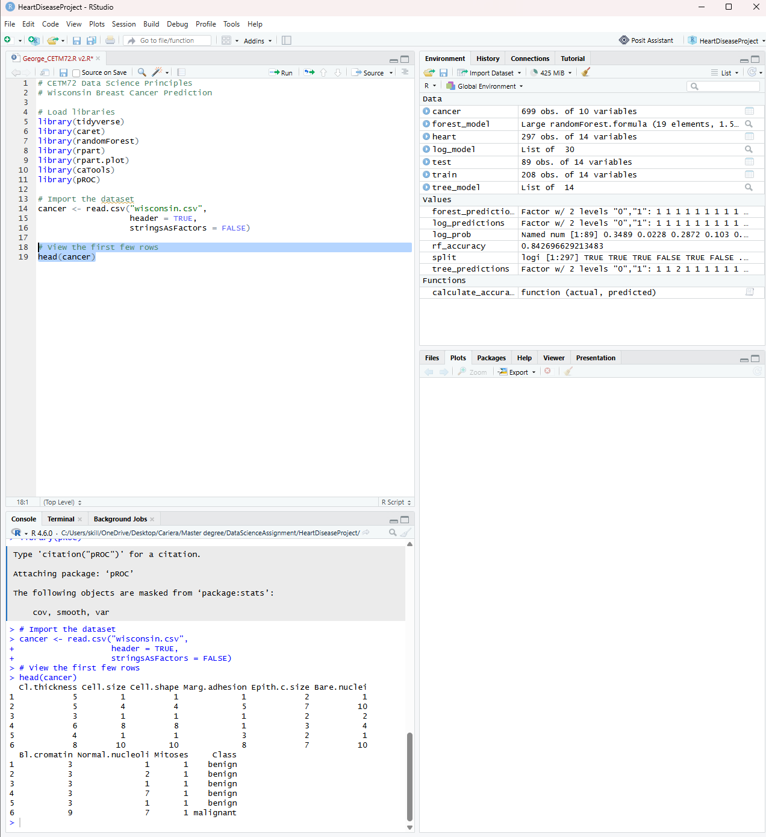

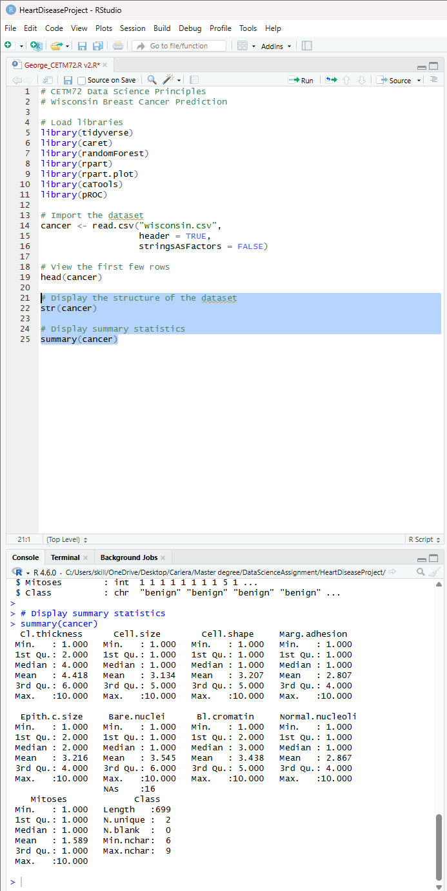

3. Machine Learning Algorithms
For this project, I chose to use two different machine learning algorithms- Decision Tree and Random Forest, I selected these models because they are commonly used for classification problems and provide a good comparison between a simple interpretable model and a more advanced ensemble method.The Decision Tree algorithm classifies data by creating a tree like structure where each decision is based on one of the variables in the dataset. One of its main advantages is that it is easy to understand and provides a visual representation of how predictions are made (Quinlan, 1986).The Random Forest algorithm builds many decision trees and combines their predictions to produce a final result, this usually improves prediction accuracy and reduces the risk of overfitting compared with a single Decision Tree (Breiman, 2001).
To evaluate the performance of both models, I used confusion matrices, prediction accuracy and a Receiver Operating Characteristic (ROC) curve these evaluation methods allowed me to compare the models and identify which algorithm produced the most reliable classification results.

4. Practical: Pre processing of Data
Before building the machine learning models I carried out several pre processing steps to prepare the Wisconsin Breast Cancer dataset for analysis. First, I imported the dataset into RStudio using the read.csv function, I then explored the data using the head, str, summary and dimfunctions to understand the variables, the structure of the dataset and the overall distribution of the data.The next step was to check for missing values using the colSums(is.na) function. I removed the ID column because it only identifies each patient and does not contribute to predicting whether a tumour is benign or malignant. The Class variable was converted into a factor so that it could be used correctly by the machine learning algorithms. Any incomplete records were then removed using the na.omit function to ensure that only complete observations were used during model training.
Finally, I split the dataset into training and testing sets using a 70:30 ratio. The training dataset was used to build the machine learning models, while the testing dataset was used to evaluate how accurately the models classified previously unseen cases.

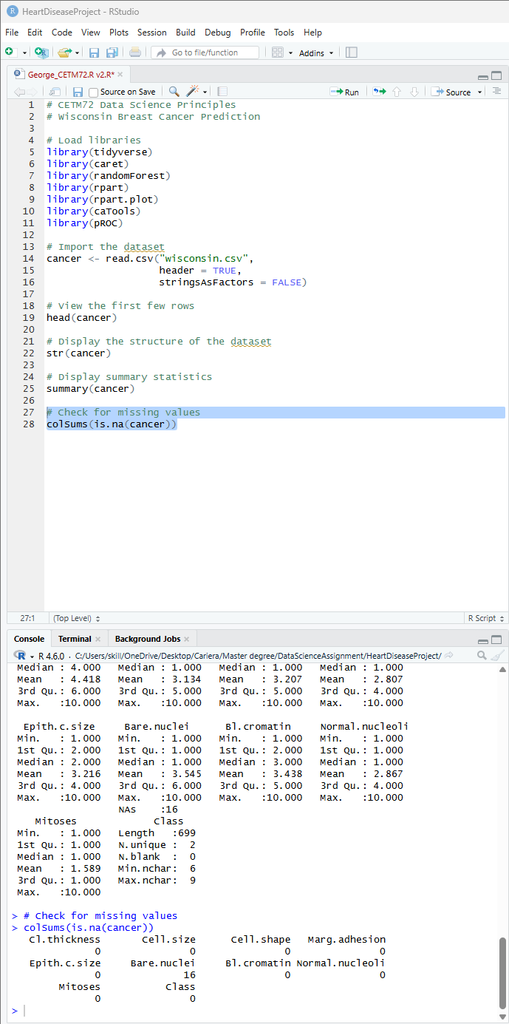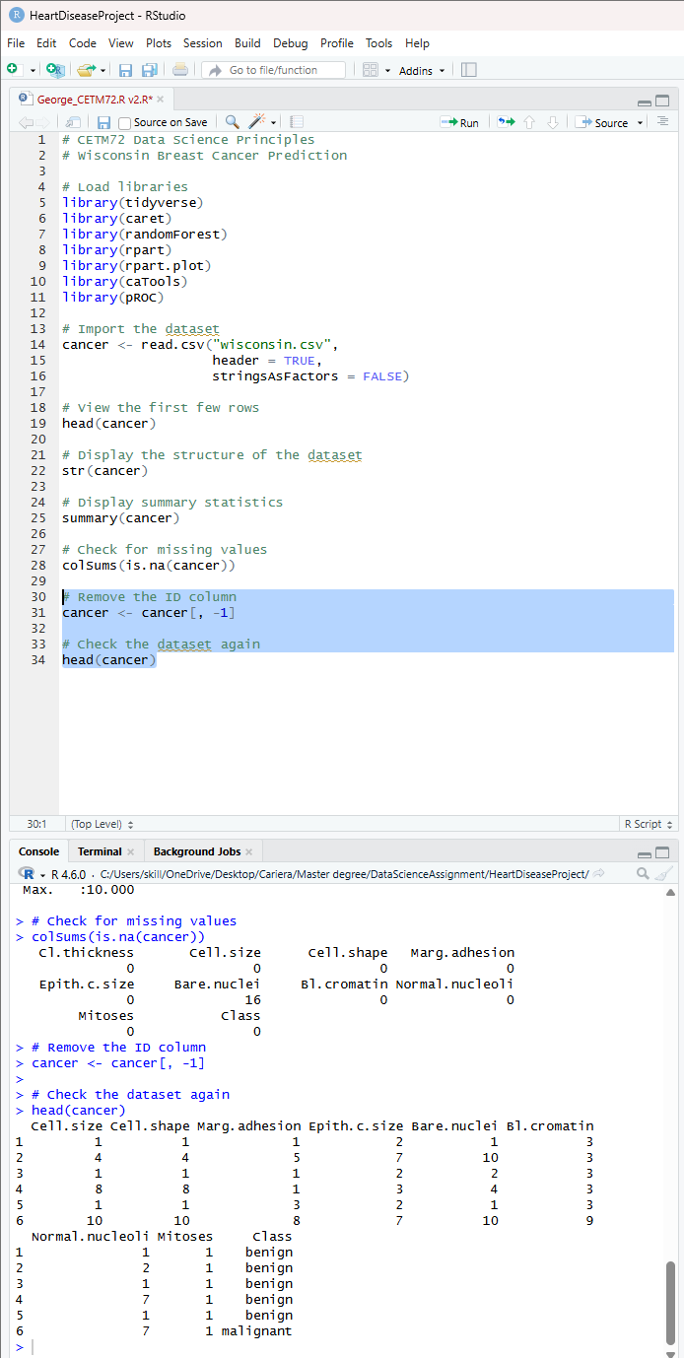

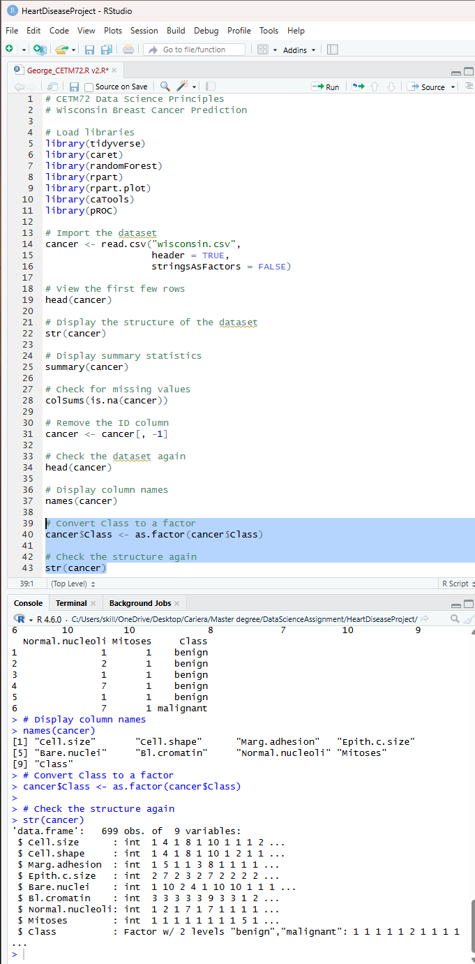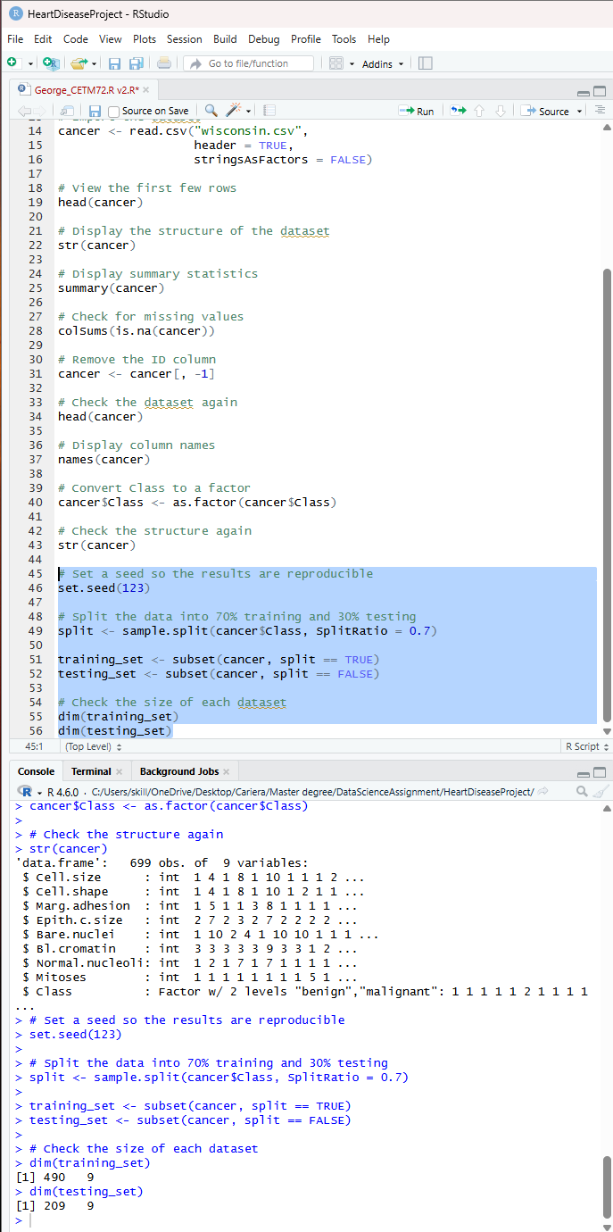

5. Practical: R Programming Content
The practical implementation of this project was completed using the R programming language in RStudio. After importing and pre-processing the Wisconsin Breast Cancer dataset, I developed two machine learning models to classify tumours as either benign or malignant.The first model I implemented was a Decision Tree using the rpart package the model was trained using the training dataset and then used to predict the class of each observation in the testing dataset. After generating the predictions, I evaluated the model by producing a confusion matrix, which compared the predicted classifications with the actual values. The Decision Tree also generated a visual representation of the classification process, making it easy to understand how different variables influenced the final prediction.

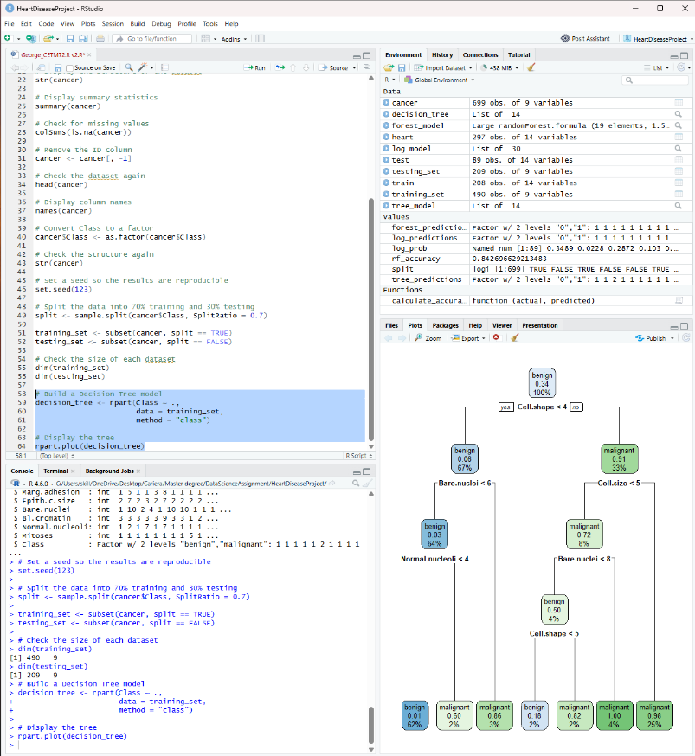

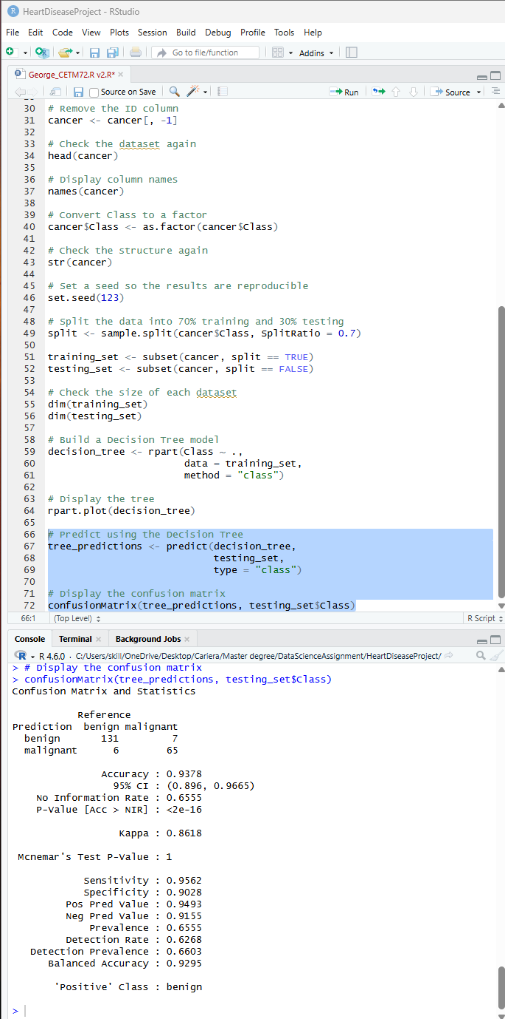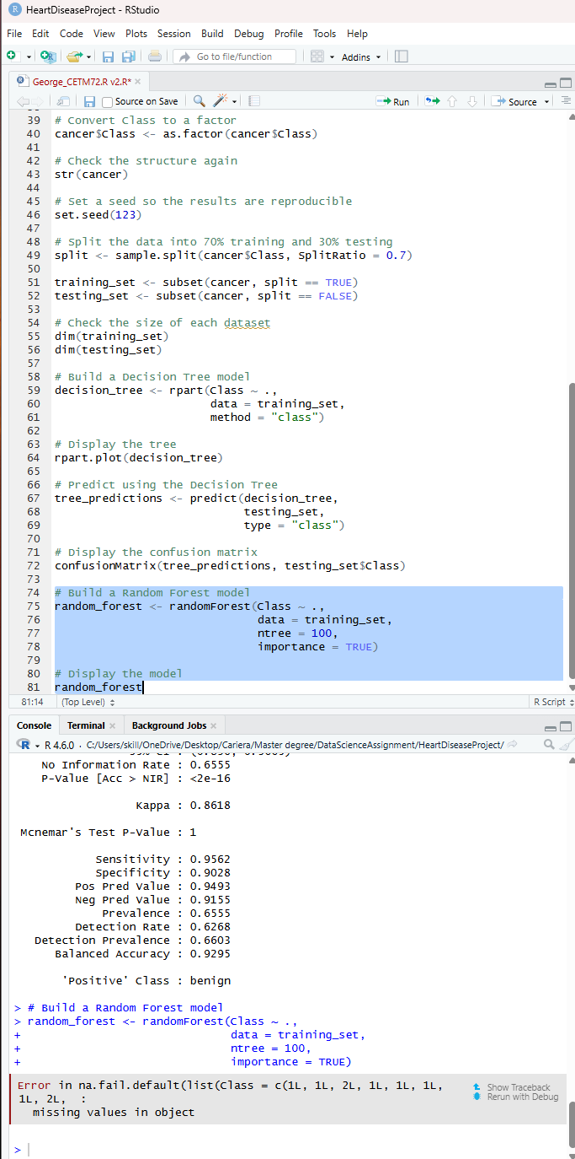

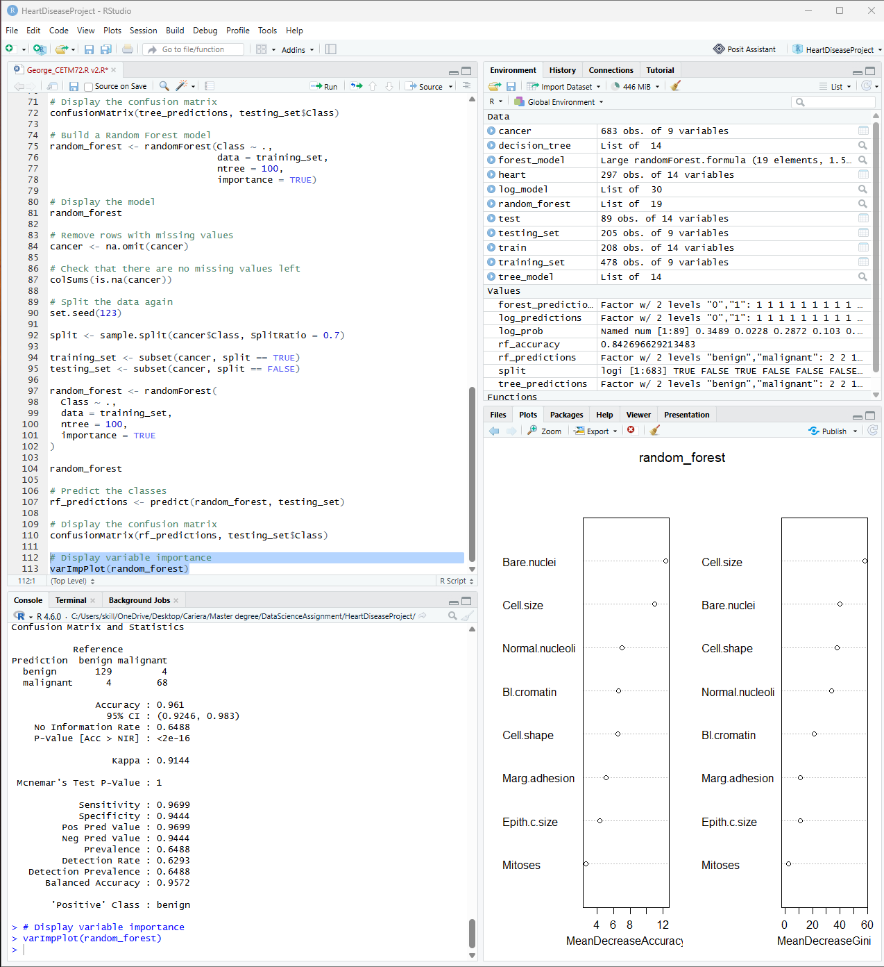
6. Practical: Display of Data Results
After developing the machine learning models, I evaluated their performance using the testing dataset. Both the Decision Tree and Random Forest models were able to classify breast cancer cases as either benign or malignant, but their performance differed.The Decision Tree model provided a clear visual representation of the classification process, making it easy to understand how the different variables were used to reach a prediction. The confusion matrix showed that the model was able to classify most observations correctly, although some cases were misclassified. While the Decision Tree was simple to interpret, its overall performance was lower than that of the Random Forest model.

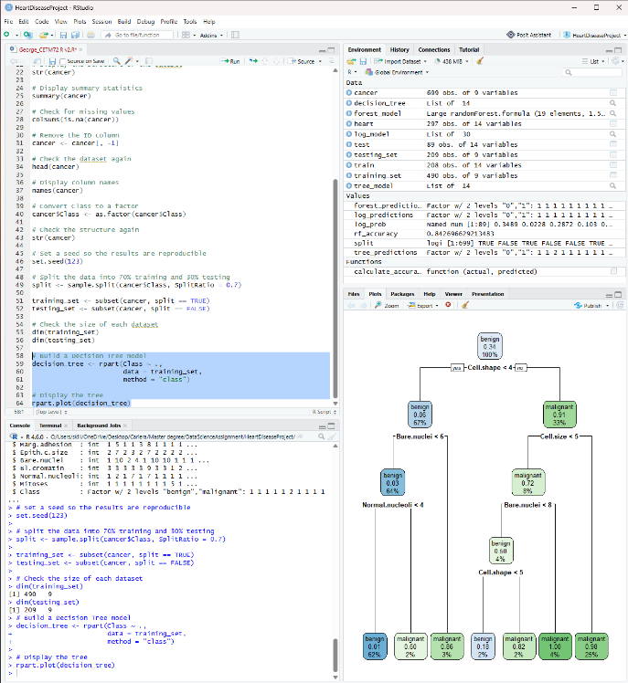

The Random Forest model produced better classification results than the Decision Tree.,the confusion matrix showed that the majority of observations were classified correctly, resulting in a higher prediction accuracy. This demonstrates the advantage of combining multiple decision trees into a single model, allowing Random Forest to produce more reliable predictions.The variable importance plot showed that some variables contributed more to the classification process than others. In particular, Bare nuclei, Cell size and Cell shape were identified as the most influential variables when predicting whether a tumour was benign or malignant. To further evaluate the Random Forest model, I generated a Receiver Operating Characteristic (ROC) curve and calculated the Area Under the Curve (AUC). The model achieved an AUC value of approximately 0.99, indicating excellent classification performance, an AUC value close to 1 suggests that the model can distinguish very effectively between benign and malignant tumours, demonstrating that the Random Forest model is highly reliable for this dataset.Overall, the results show that although both machine learning models performed well, the Random Forest model achieved the best overall performance, its higher prediction accuracy and excellent AUC value make it the most suitable model for classifying the Wisconsin Breast Cancer dataset used in this project.

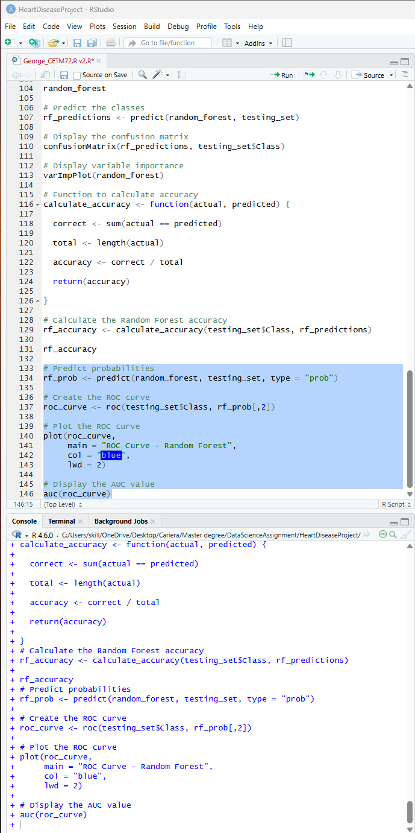
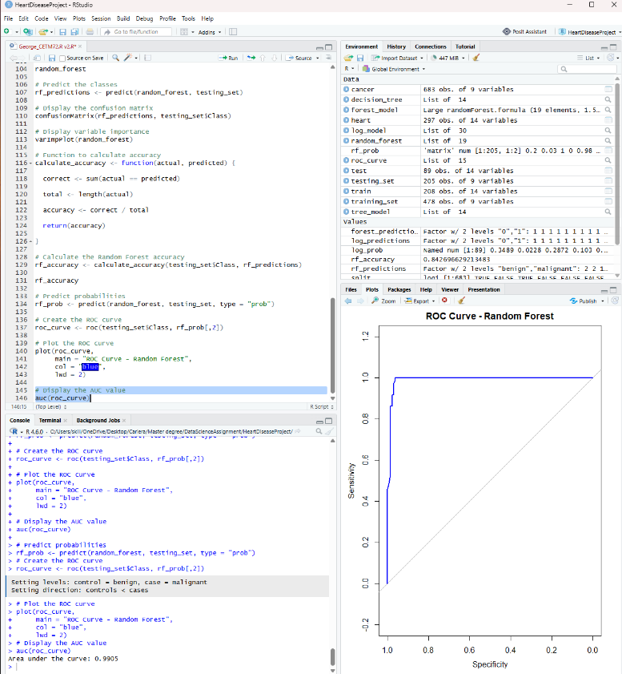

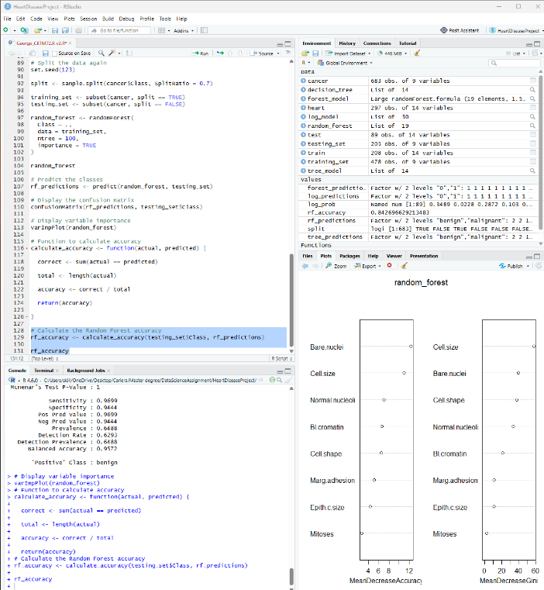

7. Conclusion
The aim of this project was to investigate whether machine learning techniques could be used to classify breast cancer cases using the Wisconsin Breast Cancer dataset. Throughout the project, I imported and explored the dataset, carried out data preprocessing, and developed two machine learning models using RStudio a Decision Tree and a Random Forest.The results showed that both models performed well when classifying tumours as benign or malignant. However, the Random Forest model achieved the highest performance, with an accuracy of approximately 96.1% and an AUC value of 0.9905, demonstrating excellent classification ability. The variable importance analysis also showed that features such as Bare.nuclei, Cell.size, and Cell.shape had the greatest influence on the predictions.
Completing this project helped me improve my understanding of the complete machine learning process, including data exploration, preprocessing, model development, model evaluation, and interpreting the results. It also strengthened my practical R programming skills by allowing me to build machine learning models, create a reusable function to calculate prediction accuracy, and evaluate performance using confusion matrices and ROC analysis.
Overall, this project demonstrated how machine learning can be applied to support the early detection of breast cancer. Although these models are not intended to replace medical professionals, they can provide valuable support in assisting diagnosis and improving clinical decision-making.

References

Breiman, L. (2001) 'Random Forests', Machine Learning, 45(1), pp. 5–32.
Dua, D. and Graff, C. (2019) UCI Machine Learning Repository. Irvine, CA: University of California, School of Information and Computer Science. Available at: https://archive.ics.uci.edu/ml (Accessed: 21 June 2026).
Han, J., Kamber, M. and Pei, J. (2012) Data Mining: Concepts and Techniques. 3rd edn. Waltham, MA: Morgan Kaufmann.
Quinlan, J.R. (1986) 'Induction of Decision Trees', Machine Learning, 1(1), pp. 81–106.
Street, W.N., Wolberg, W.H. and Mangasarian, O.L. (1993) 'Nuclear feature extraction for breast tumour diagnosis', IS&T/SPIE International Symposium on Electronic Imaging: Science and Technology, pp. 861–870.

Appendix – Full R Source Code

# CETM72 Data Science Principles
# Wisconsin Breast Cancer Prediction

# Load libraries
library(tidyverse)
library(caret)
library(randomForest)
library(rpart)
library(rpart.plot)
library(caTools)
library(pROC)

# Import the dataset
cancer <- read.csv("wisconsin.csv",
header = TRUE,
stringsAsFactors = FALSE)

# View the first few rows
head(cancer)

# Display the structure of the dataset
str(cancer)

# Display summary statistics
summary(cancer)

# Display dataset dimensions
dim(cancer)

# Check for missing values
colSums(is.na(cancer))

# Remove the ID column
cancer <- cancer[, -1]

# Check the dataset again
head(cancer)

# Display column names
names(cancer)

# Convert Class to a factor
cancer$Class <- as.factor(cancer$Class)

# Check the structure again
str(cancer)

# Display the class distribution
table(cancer$Class)

# Remove rows with missing values
cancer <- na.omit(cancer)

# Check that there are no missing values left
colSums(is.na(cancer))

# Set a seed so the results are reproducible
set.seed(123)

# Split the data into 70% training and 30% testing
split <- sample.split(cancer$Class, SplitRatio = 0.7)

training_set <- subset(cancer, split == TRUE)
testing_set <- subset(cancer, split == FALSE)

# Check the size of each dataset
dim(training_set)
dim(testing_set)

# Build a Decision Tree model
decision_tree <- rpart(Class ~ .,
data = training_set,
method = "class")

# Display the tree
rpart.plot(decision_tree)

# Predict using the Decision Tree
tree_predictions <- predict(decision_tree,
testing_set,
type = "class")

# Evaluate the Decision Tree model
tree_results <- confusionMatrix(tree_predictions, testing_set$Class)

tree_results

tree_accuracy <- tree_results$overall["Accuracy"]

tree_accuracy

# Build a Random Forest model

random_forest <- randomForest(
Class ~ .,
data = training_set,
ntree = 100,
importance = TRUE
)

random_forest

# Predict the classes
rf_predictions <- predict(random_forest, testing_set)

# Evaluate the Random Forest model
rf_results <- confusionMatrix(rf_predictions, testing_set$Class)

rf_results

rf_accuracy <- rf_results$overall["Accuracy"]

rf_accuracy

# Display variable importance
varImpPlot(random_forest)

# Function to calculate accuracy
calculate_accuracy <- function(actual, predicted) {

correct <- sum(actual == predicted)

total <- length(actual)

accuracy <- correct / total

return(accuracy)

}

# Calculate the Random Forest accuracy
rf_accuracy_function <- calculate_accuracy(testing_set$Class, rf_predictions)

rf_accuracy_function

# Predict probabilities
rf_prob <- predict(random_forest, testing_set, type = "prob")

# Create the ROC curve
roc_curve <- roc(testing_set$Class, rf_prob[,2])

# Plot the ROC curve
plot(roc_curve,
main = "ROC Curve - Random Forest",
col = "blue",
lwd = 2)

# Display the AUC value
auc(roc_curve)

